**For­­ming Impressions (Module)**

**Module: Attribution Theories**

**Subtopic: Correspondent Inference Theory**-(Jones and Davis’ Theory) people make inferences based on three variables: degree of choice, expectation, and the intended consequences of the behaviour

Degree of Choice:   
-chose to act in the observed behaviour in question or was randomly chosen/ assigned

Expectation:  
-how expected a particular behaviour is  
-uncommon behaviour gives a lot more information than common behaviour (no reason to make inferences for normal behaviour)

Intended Consequences:  
-intention of behaviour  
-ex: tobacco company advertising advocating lower smoking levels (suspicious) vs familiar person/ family member advocating same position

**Subtopic: Covariation Theory**-how you determine if a given behaviour is due to an individual’s personal disposition OR the situation and circumstances  
-three variables are considered to determine if a behaviour is dispositional or situational: consistency, distinctiveness, and consensus

Consistency:  
-does the individual usually act this way in this situation?  
-if yes, can continue to seek explanation for behaviour

Distinctiveness:  
-does the individual behave differently in different situations?  
-yes🡪situational (driven by the situation)  
-no🡪dispositional (driven by his disposition) *tendency to act in a specified way

Consensus:  
-do others behave similarly in this situation?  
-yes🡪situational (everyone similarly influenced)  
-no🡪dispositional (each individual’s disposition)

**Module: The Fundamental Attribution Error**

**Subtopic: Fundamental Attribution Error**  
-often overestimate the role of dispositional factors and underestimate role of situational factors  
-ex: get cut off; “bad driver!”🡪making assumptions: bad driver, aggressive person rather than considering stress and challenges of heavy traffic  
-**Fundamental Attribution Error:** tendency to overvalue dispositional factors for the observed behaviours of other while under-valuing situational factors  
-place of the FAE in social psychology

**Subtopic: That Actor/Observer Effect**  
-FAE🡪assume behaviour of others is due primarily to dispositional factors  
-**Actor Observer Effect:** consider the situational factors for your own behaviour  
-more vulnerable to making FAE when determining causes of behaviour of others rather than own behaviour (more aware of self and therefore more aware of situational influences)

**Subtopic: Cultural Differences**  
-FAE widely observes in Western society, but not necessarily universal finding (influenced by different cultures)  
-how likely American and Indian children and adults were to attribute negative behaviour: dispositional or situational?  
-attributions made of function of age   
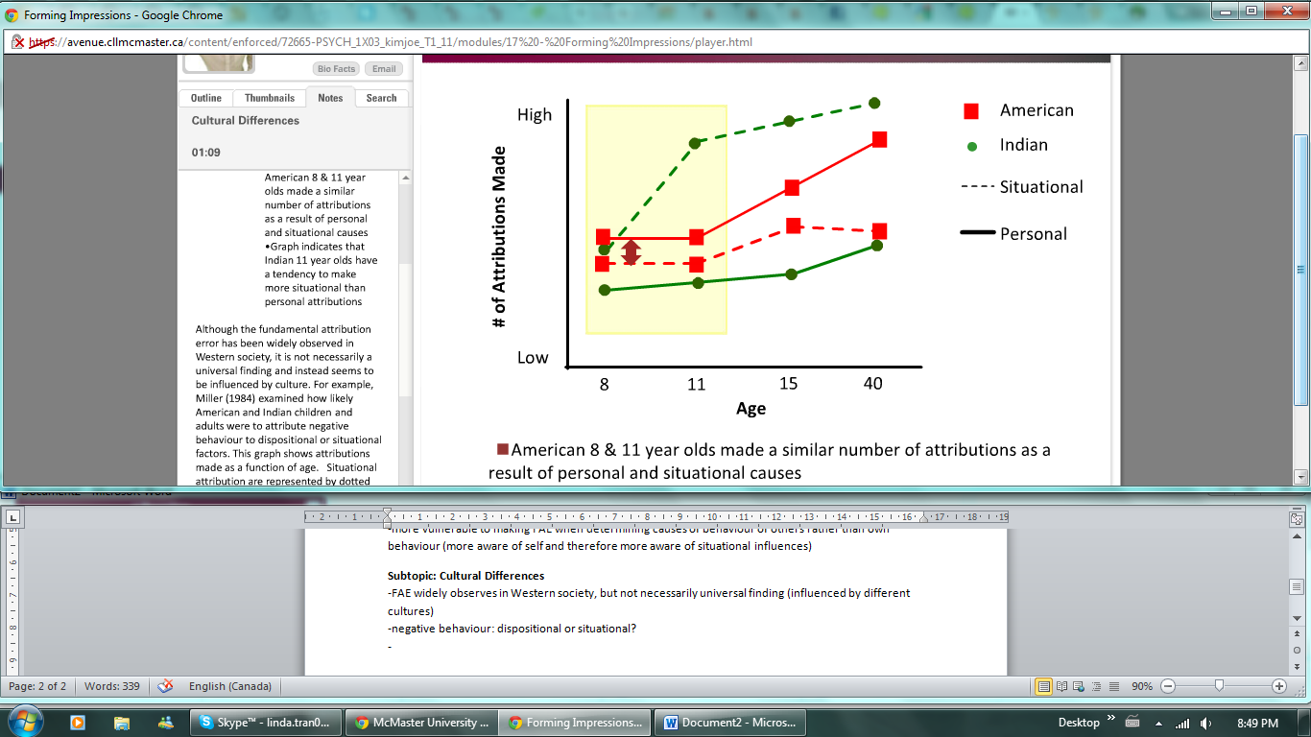 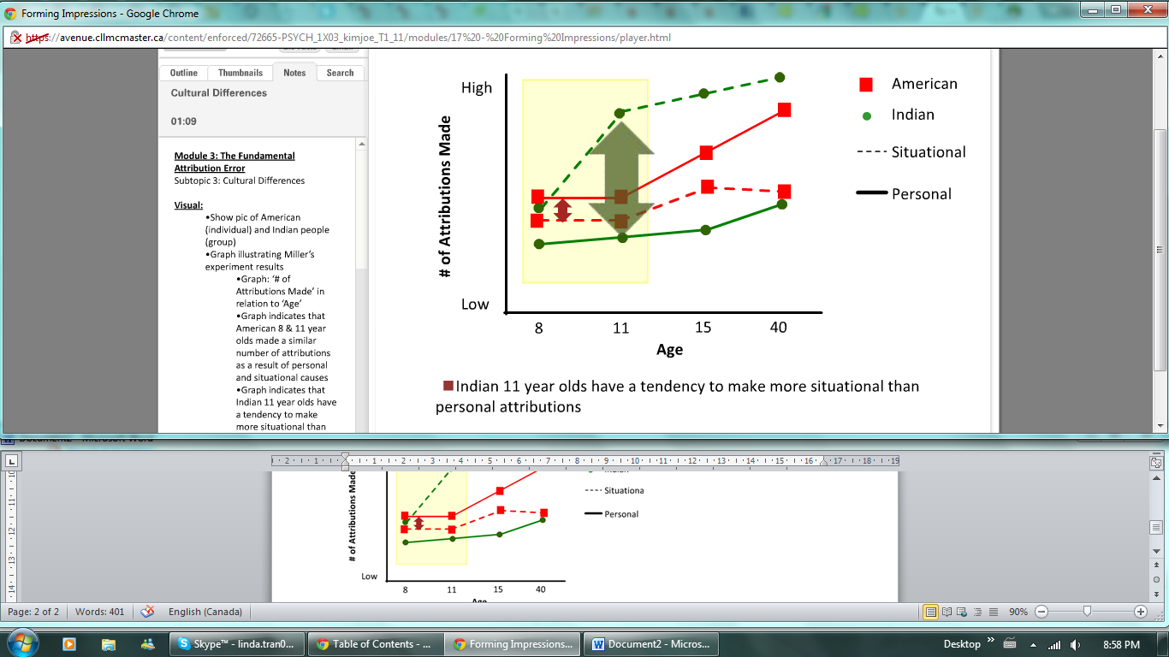  
-striking difference in two older groups  
-data suggests cultural differences in the fundamental attribution error  
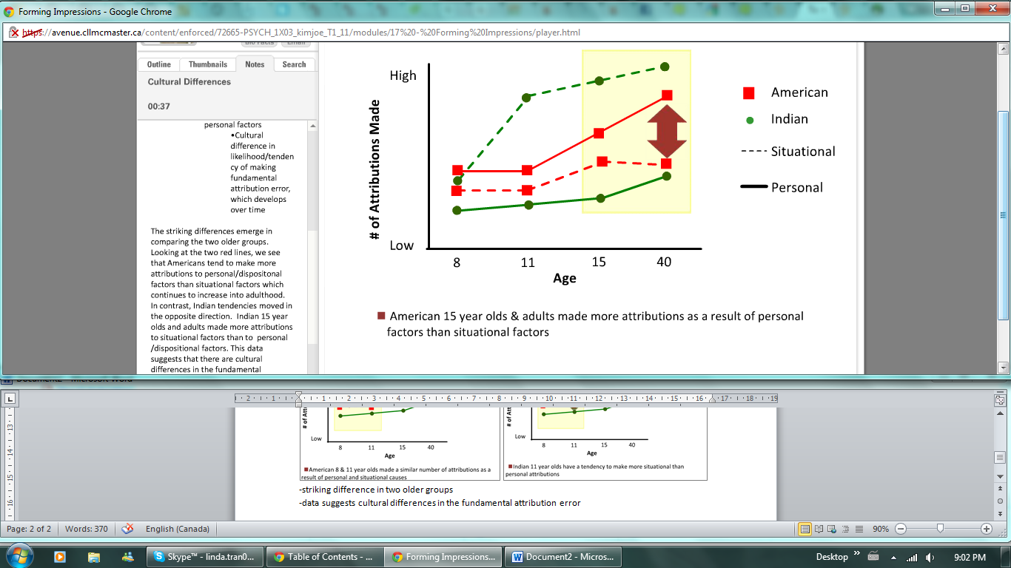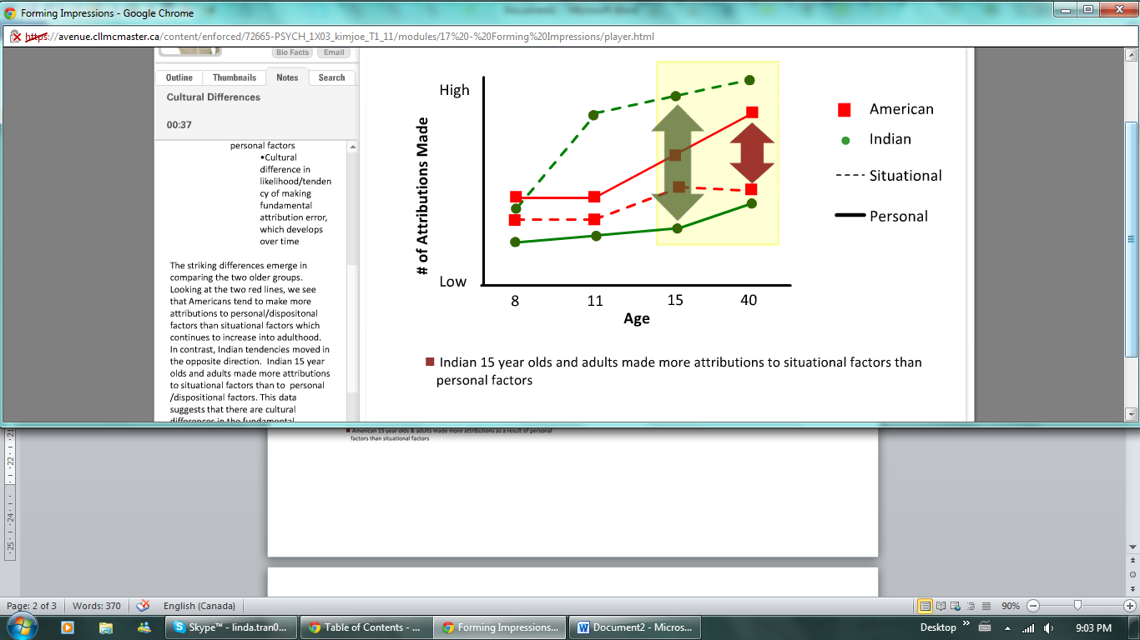  
-American: more likely to make FAE  
-Chinese: less likely to make FAE  
-FAE is diminished in collectivist societies where there is less focus in relationships and roles within society  
-American Olympic gold medal winners🡪more likely to attribute gold winning performance to their determination and talent  
-Japanese Olympic gold medal winner🡪more likely to attribute gold winning performance to the success of the coaching team and organization

**Subtopic: Self-Serving Bias**  
-tendency to perceive yourself favourably  
-**Above Average Effect:** identify dispositional causes for successes, but situational causes for failures, giving an exaggerated view of abilities  
-positive events: actors will select dispositional explanations🡪”I’m brilliant,” whereas observer🡪”Test was easy.”  
-negative events: actors will select situational explanations🡪 “Test was impossible,” whereas observers🡪 “Individual isn’t smart enough.”  
-bias in perception may lead to thinking that one is above average on many things important to the person: above average attractiveness, intelligence and social skills  
-drivers may overestimate skills, high school students overestimate social skills, etc.

**Module: Cognitive Heuristics**  
**Subtopic: Cognitive Heuristics**-social perceptions are shaped by similar heuristics (automatically use to make quick decisions about incoming information from environment) because of limited ability and formal training in analyzing   
behaviour and limited attention to put towards current task

**Subtopic: Representativeness Heuristic  
-**classify people by considering how well their behaviour fits with certain prototype  
-description given seemed more representative of a certain type of person

**Subtopic: Availability Heuristic**-number and quality of memories (positive or negative memories and the number of memories)  
-ex: given two surveys on rating courses on scale of 2-7; difference being that one survey asks for 2 problems with course and the other asks for 10 problems with course  
-easier to recall 2 problems, making it seem *relatively* *available* to your memory; gives impression that there were many problems with the course that could have been listed  
-listing 10 improvements is difficult, making it seem that problems are *not relatively available*; gives impression that there may not have been many problems with course

**Conclusion:**-every day contains opportunity for social activity  
-number of social cues processed, judgments made and decisions about responses may be overwhelming if not for short cuts  
-shortcuts may lead to biases and perceptions may not reflect reality

**Module: Relationships**

**Subtopic: Introduction**-important applications of the impressions formed of other people is found in the field of attraction research  
-attractive🡪good impression of the person and desire their company  
-four factors that make you more attracted to other people: proximity, familiarity, physical attractiveness, and peer opinions of you

Proximity:  
-physical proximity  
-more likely to be attracted to or to become friends with those you live or work with  
-importance not only in physical proximity but also in functional distance  
-functional distance: how often do two individuals get to interact?  
-familiarity explains why famous people tend to be more attractive (frequent exposure to faces)  
-when rating self, mirror image will look more attractive (used to seeing mirror image) but when asking others, they will rate the non-mirror image as being more attractive because they are used to seeing you that way in everyday life

Physical Attractiveness:  
-physically attractive🡪kind, warm, sensitive, etc. (often an important factor)  
-use the physical attractiveness on the presumption that what is beautiful is also good  
-when compared with less physically attractive people, physically attractive people are often judged as kinder, warmer, intelligent, as well as more sensitive and outgoing  
-correlational studies show that attractive people make more money and date more attractive people

Liking Those Who Like Us:  
-how much other like you; especially true when in need of a self-esteem boost  
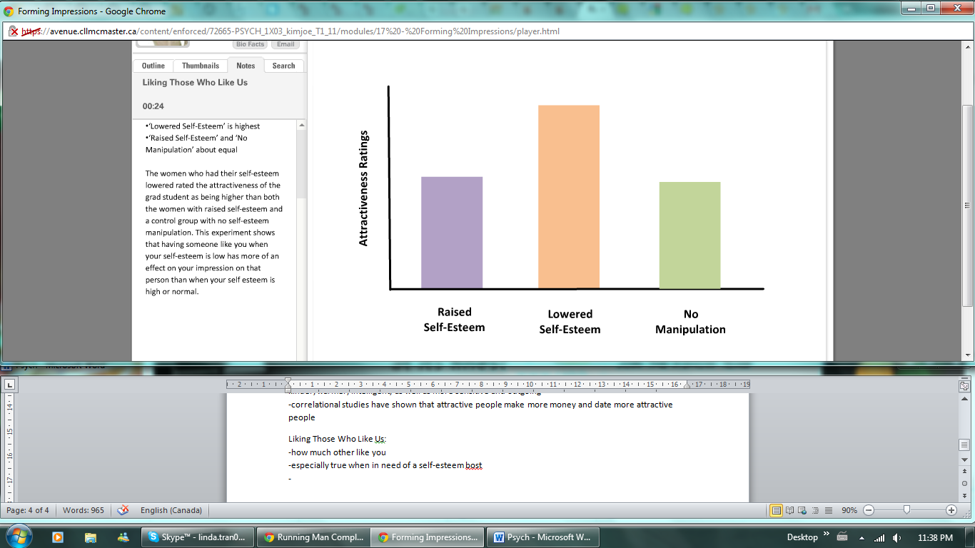 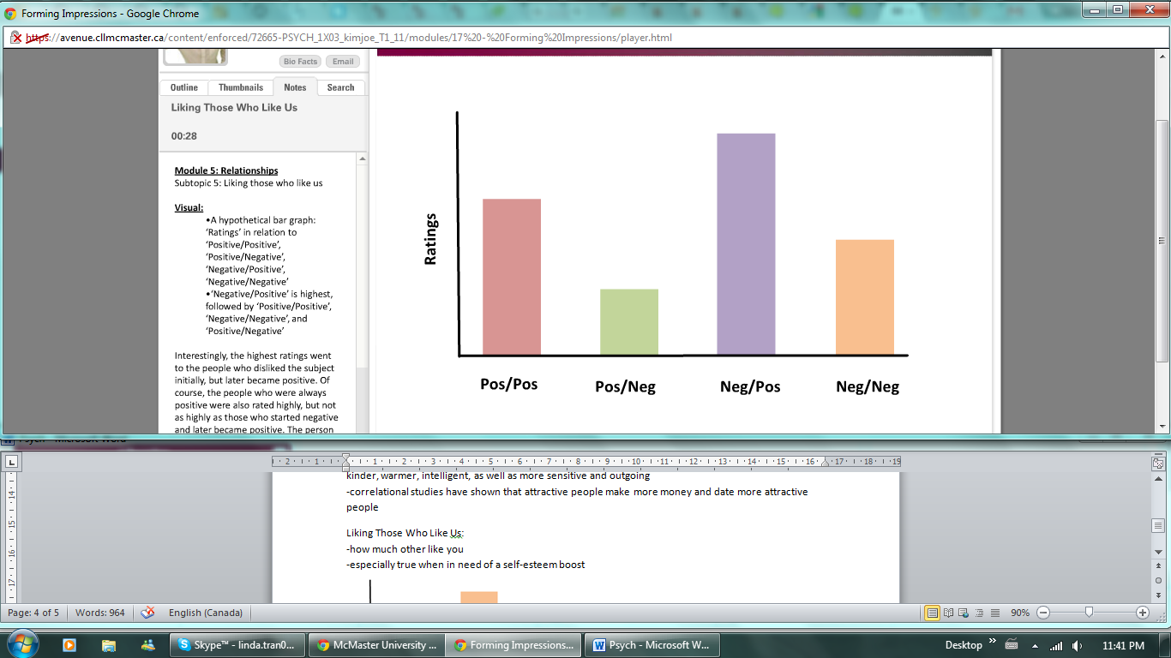  
-ratings in relation to initial views🡪ending views

**Conclusion:**-decisions about others use same heuristics as any other decisions, making one vulnerable to making the same errors